Module 3.4 – Loops

Lesson Introduction
In programming, loops allow us to execute a block of code multiple times without having to write it repeatedly.
Think of a loop as a repeating task machine.
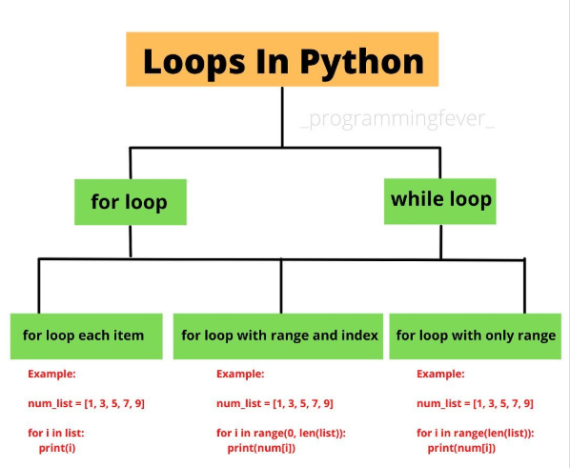

1. for loop

Definition
A for loop is used to iterate (go through) a sequence such as a list, tuple, string, or a range of numbers.

Syntax
for variable in sequence:
# code block

Example
for i in range(5):
print("Hello")

Output:
Hello
Hello
Hello
Hello
Hello

Real-World Example
Looping through student names in a class list:
students = ["Amit", "Priya", "Rahul"]
for name in students:
print(name)

2. while loop

Definition
A while loop runs as long as a given condition is true.

Syntax
while condition:
# code block

Example
count = 1
while count <= 5:
print(count)
count += 1

Output:
1
2
3
4
5

3. range() function

Definition
range() generates a sequence of numbers, often used with for loops.

Syntax
range(start, stop, step)

- start → beginning value (default = 0)
- stop → end value (exclusive)
- step → increment/decrement (default = 1)

Example
for i in range(1, 10, 2):
print(i)

Output:
1
3
5
7
9

4. Control Statements

break
Stops the loop immediately.
for i in range(5):
if i == 3:
break
print(i)

Output:
0
1
2

continue
Skips the current iteration and moves to the next one.
for i in range(5):
if i == 2:
continue
print(i)

Output:
0
1
3
4

pass
A placeholder — does nothing but keeps the code syntactically correct.
for i in range(3):
pass # to be implemented later

5. Nested Loops
A loop inside another loop.

Example
for i in range(1, 4):
for j in range(1, 3):
print(f"i={i}, j={j}")

Output:
i=1, j=1
i=1, j=2
i=2, j=1
i=2, j=2
i=3, j=1
i=3, j=2

Business Scenario
If a school has classes and students in each class, a nested loop can display every student in every class.

Practice Questions
- Write a for loop to print numbers from 1 to 10.
- Write a while loop to print even numbers from 2 to 20.
- Use range() to print numbers from 10 to 1 in reverse order.
- Write a loop that skips the number 5 but prints all others from 1–10.
- Create a nested loop that prints a multiplication table from 1–3.

1. Reverse a String
def reverse_string(s: str) -> str:
pass

2. Check for Palindrome
def is_palindrome(s: str) -> bool:
pass

3. FizzBuzz
def fizz_buzz(n: int) -> List[str]:
pass

4. Count Vowels in a String
def count_vowels(s: str) -> int:
pass

5. Find Max and Min in a List
def find_max_min(arr: List[int]) -> Tuple[int, int]:
pass

🔹 Intermediate Level

6. Two Sum Problem
def two_sum(nums: List[int], target: int) -> Tuple[int, int]:
pass

7. Remove Duplicates from List
def remove_duplicates(nums: List[int]) -> List[int]:
pass

8. Check for Anagrams
def are_anagrams(s1: str, s2: str) -> bool:
pass

9. Find First Non-Repeating Character
def first_unique_char(s: str) -> str:
pass

10. Merge Two Sorted Lists
def merge_sorted_lists(l1: List[int], l2: List[int]) -> List[int]:
pass

🔹 Advanced Level

11. Longest Substring Without Repeating Characters
def length_of_longest_substring(s: str) -> int:
pass

12. Group Anagrams
def group_anagrams(strs: List[str]) -> List[List[str]]:
pass

13. LRU Cache (Design)
class LRUCache:
def __init__(self, capacity: int):
pass

def get(self, key: int) -> int:
pass

def put(self, key: int, value: int) -> None:
pass

14. Validate Parentheses
def is_valid(s: str) -> bool:
pass

15. Find the Missing Number in a Sequence
def missing_number(nums: List[int]) -> int:
pass

